**LAB # 05**

**INTRODUCTION TO MATLAB**



**Spring 2024**

**CSE-301L**

**Operating System Lab**

Submitted by: **NAVEED AHMAD**

Registration No.: **22PWCSE2165**

Class Section: **B**

“On my honor, as student of University of Engineering and Technology, I have neither given nor received unauthorized assistance on this academic work.”

Submitted to:

**Dr. Safdar Nawaz Khan Marwat**

April 07, 2024.

Department of Computer Systems Engineering

University of Engineering and Technology, Peshawar

**TASK 01:**

Write a MATLAB function zprint, which takes a complex number and returns it real part,

imaginary part, magnitude, phase in radians, and phase in degrees**.**

**PROBLEM ANALYSIS:**

* Input: A complex number represented by z.
* Output: Real part (X), imaginary part (Y), magnitude (|z|), phase in radians (theta), and phase in degrees (theta_deg).

**ALGORITHM:**

* Input: Receive a complex number z.
* Extract Real and Imaginary Parts: Obtain the real part (X) and imaginary part (Y) of z.
* Calculate Magnitude: Compute the magnitude |z| using the formula magnitude = sqrt(X^2 + Y^2).
* Calculate Phase: Determine the phase theta in radians using the formula theta = atan2(Y, X).
* Convert Phase to Degrees: Convert the phase from radians to degrees (theta_deg = rad2deg(theta)).
* Output: Display the real part (X), imaginary part (Y), magnitude (|z|), phase in radians (theta), and phase in degrees (theta_deg) using fprintf.

**Code:**

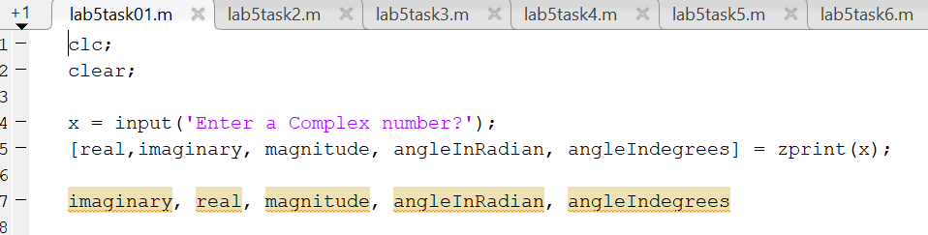

Output:

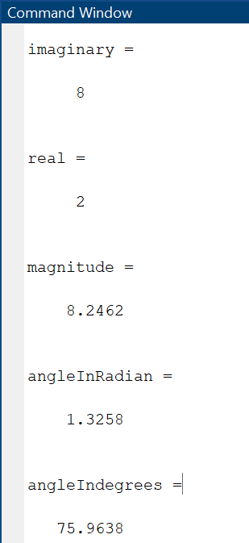

**Task 02:**

**PROBLEM ANALYSIS:**

* Input: A complex number z.
* Output: Conjugate (z_conj) and inverse (z_inv).

**ALGORITHM:**

* Input: Receive a complex number z.
* Compute Conjugate: Calculate the conjugate z_conj by negating the imaginary part of z.
* Compute Inverse: Compute the inverse z_inv by dividing 1 by z.
* Output: Display z_conj and z_inv using fprintf.

**Code:**

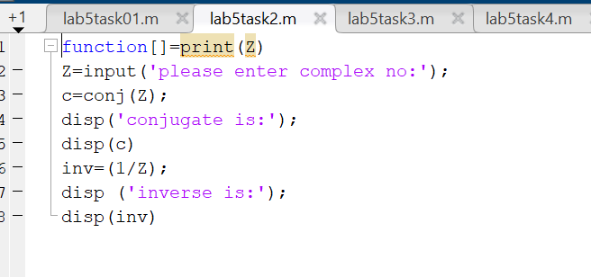

**Output:**

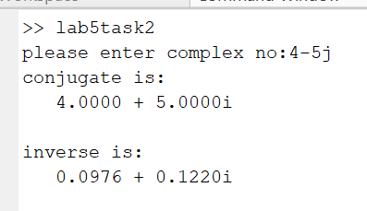

**Task 03:**

**PROBLEM ANALYSIS:**

* Input: Two complex numbers z1 and z2.
* Output: Sum z1 + z2.

**ALGORITHM:**

* Input: Receive two complex numbers z1 and z2.
* Compute Sum: Calculate the sum z1 + z2.
* Output: Display the sum using fprintf.

**Code:**

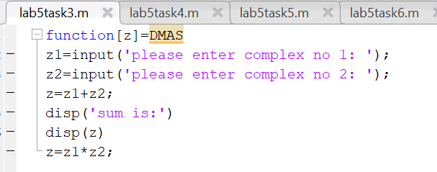

**Output:**

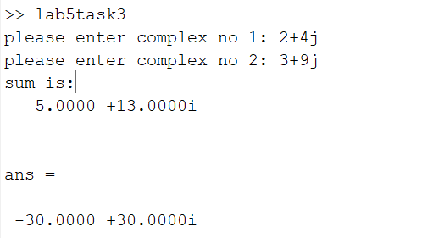

**Task 04:**

**PROBLEM ANALYSIS:**

* Input: Two complex numbers z1 and z2.
* Output: Product z1 * z2 and division z1 / z2.

**ALGORITHM:**

* Input: Receive two complex numbers z1 and z2.
* Compute Product: Calculate the product z1 * z2.
* Compute Division: Calculate the division z1 / z2.
* Output: Display the product and division using fprintf.

**Code:**

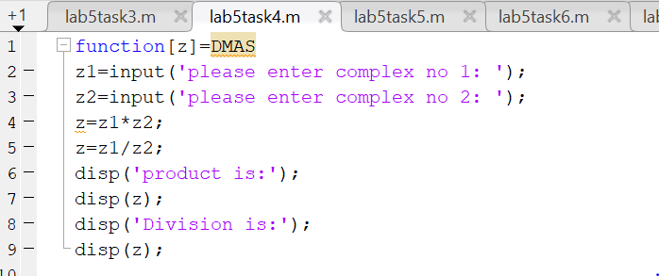

**Output:**

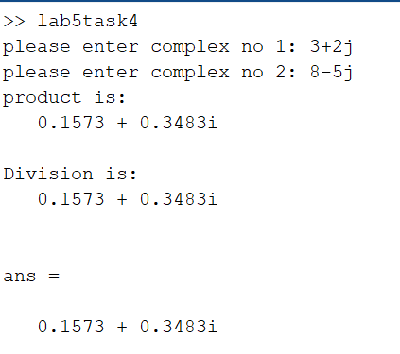

**Task 05**

**PROBLEM ANALYSIS:**

* Input: An exponential signal.
* Output: Complex conjugate of the exponential signal.

**ALGORITHM:**

* Input: Receive the exponential signal.
* Compute Complex Conjugate: Calculate the complex conjugate of the given exponential signal.
* Plot Real and Imaginary Parts: Plot the real and imaginary parts of the complex conjugate signal

**Code:**

**Output:**

**Task 06:**

**PROBLEM ANALYSIS:**

* Input: Parameters "a", "b", and "c" for the complex-valued signal "y(n) = e^(an^2 + bn + c)" for "-10 <= n <= 10".
* Output: Magnitude, phase, real part, and imaginary part of the signal, plotted in separate subplots.

**ALGORITHM:**

* Input: Receive parameters "a", "b", and "c" for the signal.
* Generate Signal: Generate the complex-valued signal "y(n) = e^(an^2 + bn + c)" for "-10 <= n <= 10".
* Compute Magnitude: Compute the magnitude of the signal.
* Compute Phase: Compute the phase of the signal.
* Compute Real and Imaginary Parts: Compute the real and imaginary parts of the signal.
* Plot Subplots: Plot the magnitude, phase, real part, and imaginary part of the signal in separate subplots.

**Code:**

**Output:**

**Task 07:**

**PROBLEM ANALYSIS:**

* Input: Parameter "a" for the real-exponential signal.
* Output: Discrete-time and continuous-time versions of the signal, plotted on the same graph.

**ALGORITHM:**

* Input: Receive the parameter "a" for the real-exponential signal.
* Generate Discrete-Time Signal: Generate the discrete-time signal "x[n] = a^n" for "0 <= n <= 10".
* Generate Continuous-Time Signal: Generate the continuous-time signal "x(t) = a^t" for "0 <= t <= 10".
* Plot Signals: Plot both the discrete-time and continuous-time signals on the same graph.

**Code:**

**Output:**

**TASK 08:**

**PROBLEM ANALYSIS:**

* Input: Two discrete signals "x1[n]" and "x2[n]".
* Output: Product of the two signals, plotted separately for "0 < a < 1" and "a > 1".

**ALGORITHM:**

* Input: Receive two discrete signals "x1[n]" and "x2[n]".
* Generate Signal "x1[n]": Generate the signal "x1[n] = 5 * exp(i * n * a)".
* Generate Signal "x2[n]": Generate the signal "x2[n] = a^n".
* Compute Product: Compute the product of the two signals "x1[n]" and "x2[n]" using point-by-point multiplication.
* Plot Real and Exponential Parts: Plot the real and exponential parts of the product signal for "0 < a < 1" and "a > 1".

**Code:**

**Output:**

**TASK 09:**

* **PROBLEM ANALYSIS:**
* Input: Parameter "a" for the signal.
* Output: Plot of the discrete signal "x[n] = a * |n|" for "-10 <= n <= 10", with two subplots for "0 < a < 1" and "a > 1".

**ALGORITHM:**

* Input: Receive the parameter "a" for the signal.
* Generate Signal: Generate the discrete signal "x[n] = a * |n|" for "-10 <= n <= 10".
* Plot Signal: Plot the discrete signal with two subplots for "0 < a < 1" and "a > 1".

**Code:**

**Output:**

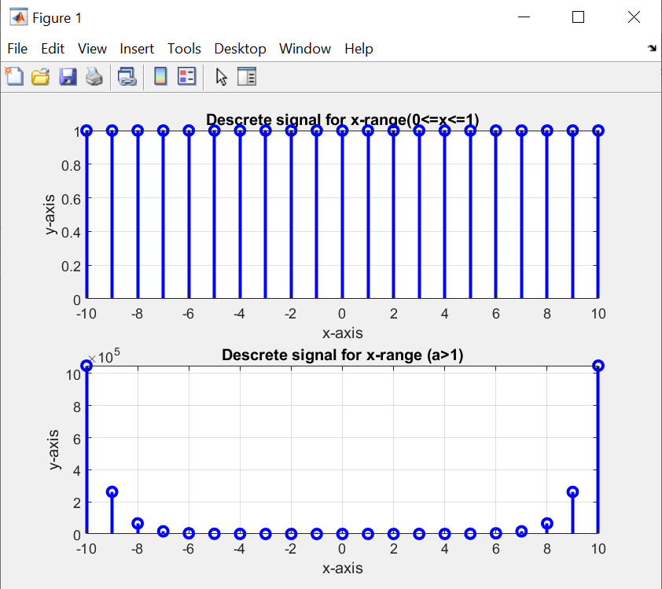

**TASK 10:**

**PROBLEM ANALYSIS:**

* Input: Parameters "A", "pi", and "omega" for the signal.
* Output: Plot of the real and imaginary parts of the signal "x(t) = A * e^(j(pi * t + omega))".

**ALGORITHM:**

* Input: Receive parameters "A", "pi", and "omega" for the signal.
* Generate Signal: Generate the signal "x(t) = A * e^(j(pi * t + omega))" over a range covering 2 or 3 periods.
* Plot Real and Imaginary Parts: Plot the real part versus "t" and the imaginary part versus "t" using subplot(2,1,i) to put both plots in the same window.

**CODE:**

**Output:**

